Basic Syntax of PHP, Variables & Constants, Data Type, Operator & Expressions, Control flow and Decision making statements, Functions, Strings, Arrays,
Understanding file& directory, Opening and closing, a file, Copying, renaming and deleting a file,
working with directories, Creating and deleting folder, File Uploading &Downloading.
Introduction to Session Control, Session Functionality What is a Cookie, Setting Cookies with PHP. Using Cookies with Sessions, Deleting Cookies, Registering Session variables, Destroying the variables and Session.
76 to 79…….83 to 87

Simple php syntax
<?php
// This is a simple PHP script

// Print a message to the console
echo "Hello, world!";

// Define a variable and assign a value
$name = "Alice";

// Print the value of the variable
echo "My name is $name.";

// Create an array
$fruits = array("apple", "banana", "orange");

// Print the third element of the array
echo $fruits[2];

// Create a function
function greet($name) {
echo "Hello, $name!";
}

// Call the function
greet("Bob");

?>
This code demonstrates the basic syntax of PHP, including:
- Comments: // for single-line comments and /* */ for multi-line comments.
- Printing: echo is used to print text to the console.
- Variables: Variables are declared using a $ sign followed by a name, and values are assigned using the = operator.
- Arrays: Arrays are created using the array() function or [] syntax.
- Functions: Functions are defined using the function keyword followed by a name and parentheses for parameters.
- Calling functions: Functions are called by using their name followed by parentheses with arguments.

"\n" in PHP is a newline character.
When you include "\n" within a string, it tells the interpreter to insert a new line at that specific point. This is useful for formatting text, creating multi-line strings, or separating different elements within a string.
Here are some common use cases for "\n":
1. Creating Multi-Line Strings:
PHP
$message = "This is the first line.\nThis is the second line.";
echo $message;
This will output:
This is the first line.
This is the second line.
2. Formatting Text:
PHP
$text = "Line 1\nLine 2\nLine 3";
echo $text;
This will output:
Line 1
Line 2
Line 3
3. Separating Elements in a String:
PHP
$data = "Name: John Doe\nAge: 30\nCity: New York";
echo $data;
This will output:
Name: John Doe
Age: 30
City: New York
In essence, "\n" is a way to control the appearance of text in your PHP output, making it more readable and structured.

PROGRAM 76

Creating PHP script that return any data types whatever you use.

<?php

// Function that returns different data types
function returnDifferentTypes($type) {
switch ($type) {
case 'string':
return "This is a string.";
case 'int':
return 42;
case 'float':
return 3.14;
case 'bool':
return true;
case 'array':
return [1, 2, 3];
case 'object':
return (object)['key' => 'value'];
default:
return "Unknown type.";
}
}

// Test the function with different types
echo returnDifferentTypes('string') . "\n";
echo returnDifferentTypes('int') . "\n";
echo returnDifferentTypes('float') . "\n";
echo returnDifferentTypes('bool') . "\n";

$arrayResult = returnDifferentTypes('array');
print_r($arrayResult);
echo "\n";

$objectResult = returnDifferentTypes('object');
print_r($objectResult);
echo "\n";

echo returnDifferentTypes('invalid') . "\n";

?>

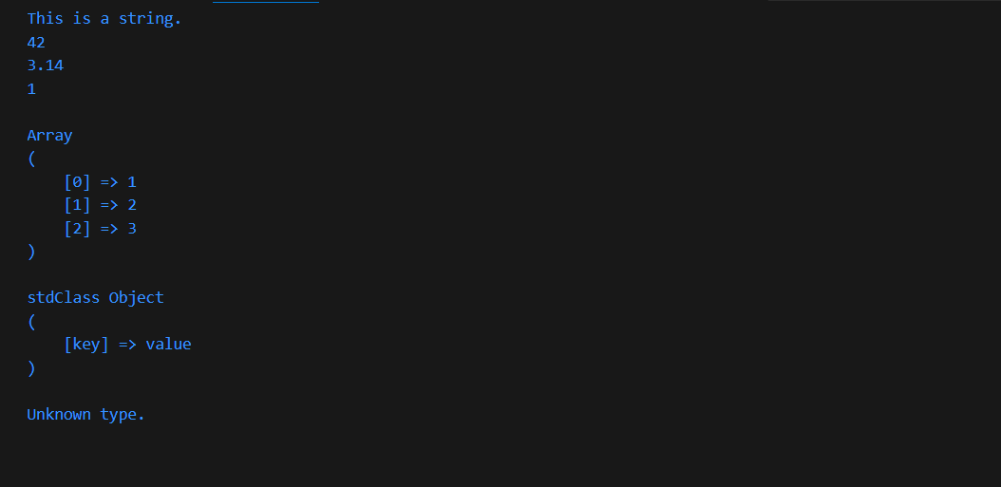

I'd be glad to provide a comprehensive explanation of the given PHP code:
Purpose:
- The code defines a function named returnDifferentTypes() that returns different data types based on the input parameter type.
- It demonstrates how to create a flexible function that can handle various data types.
Code Breakdown:
- Function Definition:
  - function returnDifferentTypes($type): Declares a function named returnDifferentTypes that takes a single parameter type.
- Switch Statement:
  - switch ($type): Begins a switch statement that evaluates the value of the type parameter.
  - Cases:
    - case 'string': If type is "string", returns the string "This is a string.".
    - case 'int': If type is "int", returns the integer 42.
    - case 'float': If type is "float", returns the floating-point number 3.14.
    - case 'bool': If type is "bool", returns the boolean value true.
    - case 'array': If type is "array", returns an array containing the elements 1, 2, and 3.
    - case 'object': If type is "object", returns an object with a key named "key" and a value of "value".
    - default: If type doesn't match any of the above cases, returns the string "Unknown type.".
- Testing the Function:
  - echo returnDifferentTypes('string') . "\n";: Prints the result of calling returnDifferentTypes with "string" as the argument, followed by a newline.
  - Similar lines are used to test the function with other data types: "int", "float", "bool", "array", and "object".
  - $arrayResult = returnDifferentTypes('array'); print_r($arrayResult); echo "\n";: Calls the function with "array" as the argument, stores the result in $arrayResult, and prints the array using print_r.
  - $objectResult = returnDifferentTypes('object'); print_r($objectResult); echo "\n";: Similar to the previous line, but with "object" as the argument.
  - echo returnDifferentTypes('invalid') . "\n";: Tests the function with an invalid type "invalid" and prints the result.
Output:
The code will output the following:
This is a string.
42
3.14
1
Array (
[0] => 1
[1] => 2
[2] => 3
)
stdClass Object (
[key] => value
)
Unknown type.
Explanation of Output:
- Each line corresponds to the result of calling returnDifferentTypes with the respective data type.
- The output demonstrates how the function correctly returns different data types based on the input.
- The print_r function is used to print arrays and objects in a human-readable format.
This code provides a clear example of how to create a versatile function in PHP that can handle various data types and return appropriate values based on the input.

One more program along with explanation
Assuming returnDifferentTypes Implementation
PHP
<?php
function returnDifferentTypes($type) {
switch ($type) {
case 'array':
return ['value1', 'value2', 'value3'];
case 'object':
$obj = new stdClass();
$obj->property1 = 'value';
$obj->property2 = 123;
return $obj;
case 'invalid':
return 'Invalid type';
default:
return 'Unknown type';
}
}

$arrayResult = returnDifferentTypes('array');
print_r($arrayResult);
echo "\n";

$objectResult = returnDifferentTypes('object');
print_r($objectResult);
echo "\n";

echo returnDifferentTypes('invalid') . "\n";
?>
Explanation of Corrected Code:
- returnDifferentTypes Implementation: The returnDifferentTypes function now includes a switch statement to handle different input types:
  - For 'array', it returns a sample array.
  - For 'object', it creates a new object with properties and returns it.
  - For 'invalid', it returns a string indicating invalid input.
  - For other unknown types, it returns a string indicating an unknown type.
Output: The code will output the following:
Array (
[0] => value1
[1] => value2
[2] => value3
)

stdClass Object (
[property1] => value
[property2] => 123
)

Invalid type
This corrected code demonstrates how to properly define and use the returnDifferentTypes function to return different types of values based on the input.

